**Comprehensive Business Performance Analysis for ShopNest Store**

By Mahendra Nimunkar

1. **Top Categories by Total Price:**
   * + - * Identify and visually represent the top 10 product categories by total sales.

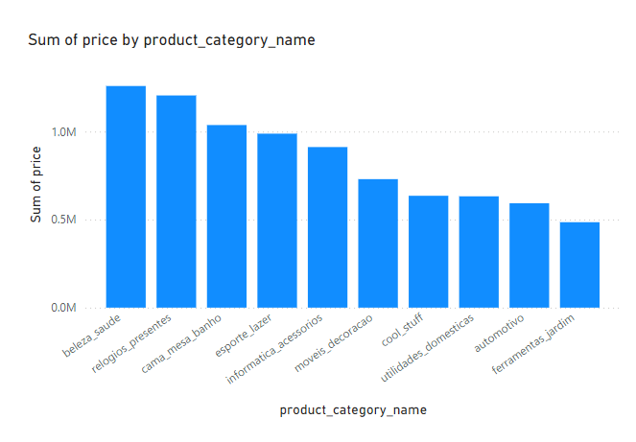

**Visual Description:**

* **Type of Chart**: Bar Chart
* **Axes**:
  + **X-Axis**: Product Categories (product_category_name)
  + **Y-Axis**: Sum of Total Sales (Sum of price)
* **Bars**: Represent the total sales for each product category.

**Key Insights and Findings:**

1. **Top Performing Categories**:
   * **Health and Beauty (beleza_saude)**: This category has the highest total sales, exceeding 1 million in sales. This indicates that products related to health and beauty are the most popular and generate the most revenue.
   * **Watches and Gifts (relogios_presentes)**: This category is closely following the top spot, also with sales over 1 million. Watches and gifts are highly sought after by customers.
2. **Significant Contributors**:
   * **Bed, Bath, and Table (cama_mesa_banho)** and **Sports and Leisure (esporte_lazer)**: Both categories show strong sales figures, making significant contributions to the overall revenue.
3. **Moderate Performers**:
   * **Computers and Accessories (informatica_acessorios)** and **Furniture and Decoration (moveis_decoracao)**: These categories have moderate sales, indicating steady demand for these products.
4. **Lower Performing Categories**:
   * **Cool Stuff (cool_stuff)**, **Domestic Utilities (utilidades_domesticas)**, **Automotive (automotivo)**, and **Tools and Garden (ferramentas_jardim)**: These categories, while still in the top 10, have relatively lower sales compared to the top performers.

**Summary:**

* The bar chart effectively highlights the top 10 product categories by total sales.
* **Health and Beauty** and **Watches and Gifts** are the leading categories in terms of revenue.
* There is a noticeable drop in total sales after the top two categories, with other categories contributing moderately.
* Understanding these insights can help in strategic decision-making, such as focusing marketing efforts on top-performing categories and exploring growth opportunities in lower-performing ones.

1. **Delayed Orders Analysis:**
   * + - * Determine the number of delayed orders in each category. An order is considered delayed if the actual delivery date is later than the estimated delivery date.

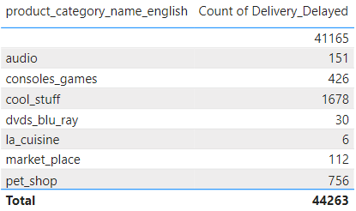

**Visual Description:**

* **Type of Chart**: Tabular Display
* **Columns**:
  + **Product Category (product_category_name_english)**: Lists each product category in English.
  + **Count of Delivery Delayed**: Shows the number of delayed orders for each category.
* **Total**: The total number of delayed orders across all categories is 44,263.

**Key Insights:**

1. **Overall High Delays**:
   * The total number of delayed orders is quite high, indicating a widespread issue with delivery times.
2. **Top Category**:
   * The first row, which is not labeled with a category name, shows an exceptionally high count of delayed orders (41,165). This might need clarification or could represent a cumulative total from a specific large category or a data entry issue.
3. **Notable Delayed Categories**:
   * **Cool Stuff (cool_stuff)**: 1,678 delayed orders, indicating a significant number of delivery issues.
   * **Pet Shop (pet_shop)**: 756 delayed orders, showing a considerable amount of delivery delays in this category.
4. **Moderate Delays**:
   * **Consoles and Games (consoles_games)**: 426 delayed orders, pointing to frequent delivery challenges.
   * **Audio (audio)**: 151 delayed orders, suggesting some delivery issues but not as severe as others.
5. **Minimal Delays**:
   * **DVDs and Blu-ray (dvds_blu_ray)**: 30 delayed orders, indicating efficient delivery in this category.
   * **La Cuisine (la_cuisine)**: Only 6 delayed orders, showing very few delivery problems.
6. **Market Place (market_place)**:
   * 112 delayed orders, suggesting some level of delivery issues but relatively lower compared to top problematic categories.

**Summary:**

* The table highlights the number of delayed orders for various product categories.
* There's a significant number of delayed orders in the cool_stuff and pet_shop categories, suggesting areas for improvement.
* Some categories like la_cuisine and dvds_blu_ray have minimal delivery delays, indicating efficient delivery systems in these areas.
* The high count in the first row requires further investigation to understand its context and impact.

1. **Monthly Comparison of Delayed and On-Time Orders:**
   * + - * Create a dynamic visual that compares the number of delayed orders to the number of orders received earlier for each month. Utilize the drillthrough cross-report feature to provide a detailed analysis of late and on-time deliveries.

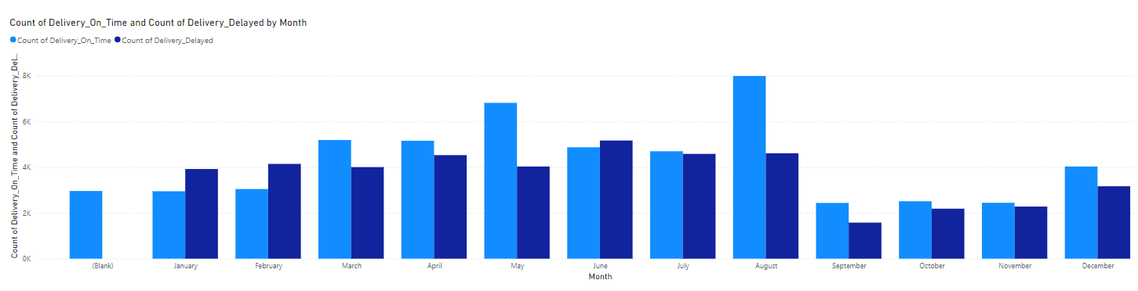

**Visual Description:**

* **Type of Chart**: Clustered Bar Chart
* **Axes**:
  + **X-Axis**: Months
  + **Y-Axis**: Count of Orders (On-Time and Delayed)
* **Bars**:
  + **Light Blue Bars**: Count of On-Time Deliveries
  + **Dark Blue Bars**: Count of Delayed Deliveries

**Key Insights:**

1. **Monthly Trends**:
   * The visual shows both on-time and delayed deliveries for each month.
   * Each month has two bars: one for on-time deliveries and one for delayed deliveries.
2. **Peak Periods**:
   * **August**: This month has the highest number of on-time deliveries, significantly more than any other month. However, it also has a substantial number of delayed deliveries.
   * **March** and **May**: Both months also show high activity in terms of order deliveries, with a notable count of on-time deliveries slightly higher than delayed ones.
3. **Consistent Patterns**:
   * **February, April, June, and July**: These months have relatively balanced counts of on-time and delayed deliveries, with a slight edge towards on-time deliveries.
4. **Low Activity Periods**:
   * **September**: This month has the lowest activity in terms of both on-time and delayed deliveries.
   * **October and November**: These months show moderate activity with balanced counts of deliveries, similar in trend to each other.
5. **End of the Year**:
   * **December**: Shows an increase in activity compared to the preceding months, with a higher count of on-time deliveries but also a significant count of delayed deliveries.

**Summary:**

* The chart provides a clear month-by-month comparison of on-time versus delayed deliveries.
* **August** stands out with the highest delivery counts, indicating it may be a peak shopping season.
* **September** shows the lowest delivery counts, suggesting it may be an off-peak month.
* There is a general trend where on-time deliveries often exceed delayed deliveries, except for specific months where the gap is narrower.

1. **Payment Method Analysis:**
   * + - * Analyse the most frequently used payment methods by customers using a visually appealing representation, such as a pie chart or other suitable visuals.

#### Visual Description:

* **Type of Chart**: Pie Chart
* **Segments**: Each segment represents a different payment method.
* **Size of Segments**: The size of each segment corresponds to the proportion of orders made using that payment method.

#### Key Insights:

1. **Most Used Payment Method**:
   * **Credit Card**: The largest segment (dark blue) represents credit card payments, accounting for 73.92% of all orders (76.8K orders). This indicates that the majority of customers prefer using credit cards for their purchases.
2. **Second Most Used Payment Method**:
   * **Boleto**: The second largest segment (light blue) represents payments made using boleto, making up 19.04% of all orders (19.78K orders). This is a significant portion, showing that a notable number of customers prefer this method.
3. **Other Payment Methods**:
   * **Voucher**: Represented by the pink segment, voucher payments account for 5.56% of the orders (5.78K orders). This shows some preference for voucher payments, but it is less common compared to credit card and boleto.
   * **Debit Card**: The orange segment represents debit card payments, which are very minimal (0% of the orders). This suggests that very few customers use debit cards for their purchases.
   * **Not Defined**: The smallest segment (purple) indicates orders with an undefined payment method, which are negligible (0%).

#### Summary:

* **Credit Card Dominance**: The majority of customers (nearly three-quarters) prefer using credit cards for their transactions.
* **Boleto as a Popular Alternative**: Nearly one-fifth of the customers use boleto, making it the second most popular payment method.
* **Lesser Used Methods**: Voucher payments are used by a smaller segment of customers, while debit cards and undefined methods are almost non-existent.

### **Strategic Implications:**

* **Focus on Credit Card Users**: Since most transactions are made via credit card, ensuring a smooth and secure credit card payment process should be a priority.
* **Boleto Convenience**: Given its popularity, making the boleto payment process as convenient as possible could enhance customer satisfaction and potentially increase sales.
* **Exploring Lesser Used Methods**: Understanding why debit card usage is minimal and addressing any barriers might offer an opportunity to increase its use.

1. **Product Rating Analysis:**
   * + - * Determine the top 10 highest-rated products and the bottom 10 lowest-rated products using a bar or column chart.

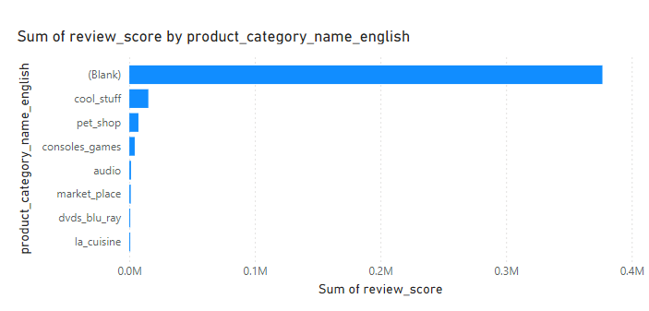

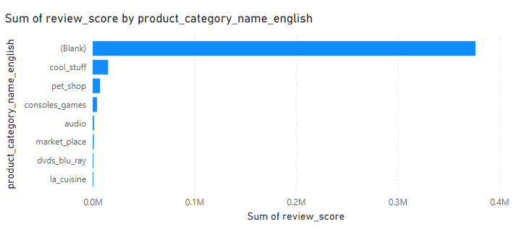

#### Top 10 Highest-Rated Products

* **Chart Type**: Bar Chart
* **X-Axis**: Sum of Review Scores
* **Y-Axis**: Product Categories
* **Key Insight**:
  + **Cool Stuff**: Highest total review scores among named categories.
  + **Pet Shop** and **Consoles and Games**: Also show strong positive feedback.

#### Bottom 10 Lowest-Rated Products

* **Chart Type**: Bar Chart
* **X-Axis**: Sum of Review Scores
* **Y-Axis**: Product Categories
* **Key Insight**:
  + **Cool Stuff** and **Pet Shop**: Appear again, indicating mixed customer experiences.
  + **Other Categories**: Lower total review scores suggest less favorable feedback.

### **Summary:**

* **Top Performers**: Categories like Cool Stuff and Pet Shop have high ratings.
* **Mixed Feedback**: Some categories appear in both top and bottom ratings, indicating variability in customer satisfaction.
* **Data Cleaning Needed**: Large blank category indicates a need for better data categorization.

1. **State-wise Sales Analysis:**
   * + - * Identify and visually represent states with high and low sales, providing a clear understanding of regional sales performance.

#### C:\Users\Mahendra Nimunkar\OneDrive\Pictures\Screenshots\Screenshot 2024-06-24 022552.png

#### 

#### High Sales States

* **Chart Type**: Bar Chart
* **X-Axis**: Total Sales Amount
* **Y-Axis**: States with High Sales
* **States with High Sales**:
  + **SP (São Paulo)**: Leads significantly with the highest sales.
  + **RJ (Rio de Janeiro)**: Second-highest sales, following São Paulo.
  + **MG (Minas Gerais)**: Third in line with notable sales.
  + **RS (Rio Grande do Sul)**, **PR (Paraná)**, **SC (Santa Catarina)**, **BA (Bahia)**, **DF (Distrito Federal)**, **GO (Goiás)**, **ES (Espírito Santo)**: Show moderate to high sales but are behind the top three states.

#### Low Sales States

* **Chart Type**: Bar Chart
* **X-Axis**: Total Sales Amount
* **Y-Axis**: States with Low Sales
* **States with Low Sales**:
  + **PI (Piauí)**, **RN (Rio Grande do Norte)**, **AL (Alagoas)**, **SE (Sergipe)**, **TO (Tocantins)**: These states have the highest sales among the lower-performing states but still significantly less than the top states.
  + **RO (Rondônia)**, **AM (Amazonas)**, **AC (Acre)**, **AP (Amapá)**, **RR (Roraima)**: Represent the lowest sales regions, indicating the least customer engagement or smaller markets.

### **Summary:**

* **Top Performers**: São Paulo, Rio de Janeiro, and Minas Gerais lead in sales, indicating high customer activity and market engagement.
* **Moderate Performers**: Several states like Rio Grande do Sul, Paraná, and Santa Catarina show substantial but lower sales compared to the top states.
* **Low Performers**: States like Piauí, Rio Grande do Norte, and others in the lower sales chart represent smaller markets or less customer activity.

1. **Seasonal Sales Patterns:**
   * + - * 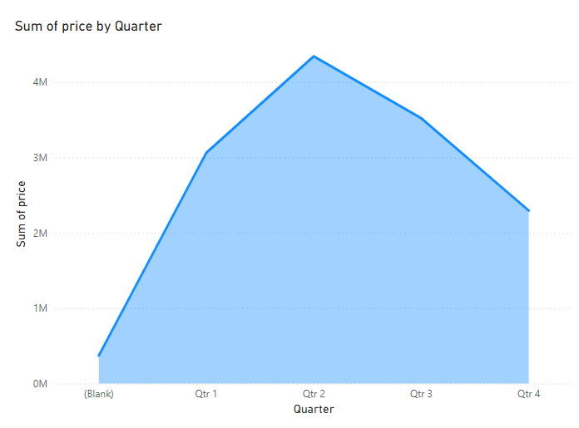Investigate and visualize any seasonal patterns(Quarterly) or trends in sales data over the course of the year.

**Visual Description:**

* **Type of Chart**: Area Chart
* **X-Axis**: Quarters of the year (Q1, Q2, Q3, Q4)
* **Y-Axis**: Total Sales Amount
* **Area**: Represents the sum of sales over each quarter

#### Key Insights:

1. **Quarter 1**:
   * **Sales Growth**: There is a noticeable increase in sales from the start of the year, suggesting a positive sales trend early in the year.
2. **Quarter 2**:
   * **Peak Sales**: This quarter shows the highest sales, indicating it is the most lucrative period of the year. Factors contributing to this peak could include seasonal promotions, holidays, or other events driving customer purchases.
3. **Quarter 3**:
   * **Slight Decline**: Sales start to decline after the peak in Q2, but they remain relatively high. This indicates sustained customer interest and purchasing behaviour through mid-year.
4. **Quarter 4**:
   * **Further Decline**: Sales drop more significantly in the last quarter of the year. This could be due to seasonality factors such as post-holiday slowdowns or budget constraints as the year ends.

### **Summary:**

* **Strongest Sales Period**: Quarter 2, with the highest sales, should be a focus for marketing and sales strategies.
* **Early Year Growth**: Quarter 1 shows a strong growth trend, indicating a good period to initiate marketing campaigns.
* **Mid-Year Stability**: Quarter 3, although declining from Q2, still shows strong sales, suggesting stable market conditions.
* **Year-End Strategy**: Quarter 4’s decline indicates a need for strategic planning, possibly through holiday promotions or end-of-year sales to boost revenue.

1. **Revenue Analysis:**
   * + - * Determine the total revenue generated by ShopNest Store and analyse how it changes over time(Yearly). Represent this information through suitable visuals to highlight trends and patterns.

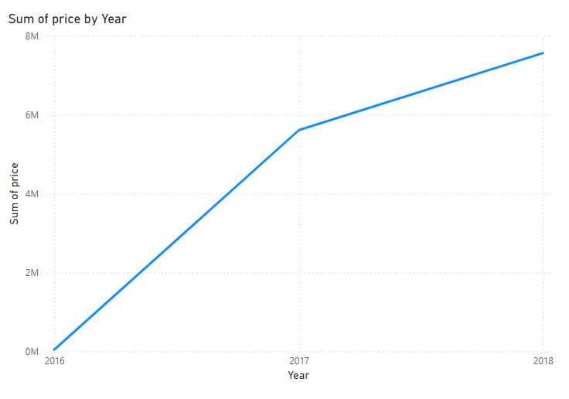

#### Visual Description:

* **Type of Chart**: Line Chart
* **X-Axis**: Years (2016, 2017, 2018)
* **Y-Axis**: Total Revenue
* **Line**: Represents the total revenue generated by ShopNest Store over each year.

#### Key Insights:

1. **2016**:
   * **Initial Revenue**: The chart starts at zero, indicating either the beginning of data collection or the start of operations for ShopNest Store.
   * **Steady Growth**: There is a sharp increase in revenue throughout the year, showing strong initial growth.
2. **2017**:
   * **Continued Growth**: Revenue continues to rise significantly, with the year ending at a higher total than 2016. This indicates sustained business growth and possibly expanding customer base and product offerings.
   * **Stabilization Mid-Year**: There is a noticeable leveling off in the middle of the year before growth picks up again.
3. **2018**:
   * **Strong Performance**: The upward trend continues, with revenue reaching its highest point by the end of the year. This consistent increase suggests ongoing success and effective business strategies.

### **Summary:**

* **Overall Trend**: There is a clear upward trend in revenue from 2016 to 2018, indicating successful business operations and growth.
* **Key Growth Periods**: Significant growth periods are observed at the start and end of each year, with a slight stabilization mid-year in 2017.
* **Implications**: This positive trend suggests effective management and market strategy, potentially involving successful marketing campaigns, customer acquisition, and product diversification.